**VISUALIZATION**

In this era , visualization is very important concept which is used in every industry to understand the trends of markets , insightful strategies , and to learn the overall pattern from millions and trillions or may be billions of data . so there are some libraries in python through this we can be able to do some visualization such as matplotlib , seaborn and many more

1st :- **MATPLOTLIB**

**Pyplot represents as pythonic plot**

**For labelling we will use label function**

* **Scatter plot:-**

* **Now we can do some operations in graph like change of colours , size of points, intensity**

**First we will define this colour by generating some random data , remember that the shape of the data should be same of x and y data which is been used inside the plot so Here co and sizes are the variables which distinguishes for colours and sizes**

**In scatter plot there are some parameters like c indicates for colours and s indicates for sizes**

**Since sizes are so small so we can multiply it with big number and increase the size .**

**Alpha parameter shows the intensity of colour**

**It ranges from 0 to 1 AT zero it is very low and at 1 it is like original colour .**

* **Bar graph:- Bar graph is used for representing the categorical data with numerical values .**

**If I want to show this data in Horizantal mode then use barh instead of bar**

**We can do some decorations in above graph also in sinusoidal wave graph**

**We can also control the figure size means the graph size of the graph by using figure function and figsize as a parameter.**

**With the help of colour code we can give any color to the graph, so by using html color code by putting the # values we can give any color to the graph example of scatter plot given below**

**If we don’t want circles or points for locating the data then we can give our own points for locating the data by using marker function.**

* **Histogram :- Histogram graph is used for representing the repetation of numbers used in the graph.**

**In this the y – axis shows the frequency of the occurrence of the data where else x – axis shows the distribution of the data**

* **3 – D graph**

**To show graph in 3 -D then we have to add the plot by using add_subplot**

**1st step :- allocate the figure to one variable example fig=plt.figure()**

**2nd step:- use the add_subplot() function in that use parameter known as projection and give projection =”3d”**

**3rd step then plot**

**Example given below**

**SEABORN**

* **SEABORN :- This is another library of python which is used for visualization just like matplotlib.**

**There are some default data sets which are present in seaborn**

**To show some relation ships we will use scatter plot to find relationship**

**So,**

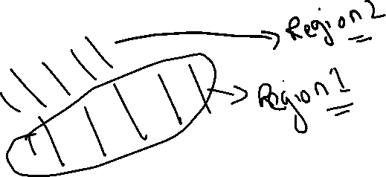

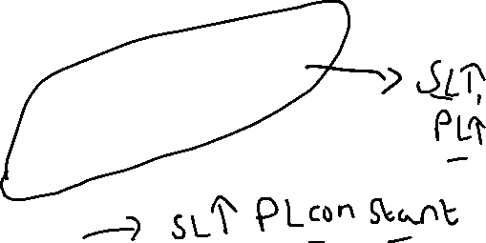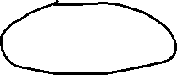

In seaborn distance plot(displot) is equivalent to histogram in matlplotlib its same like histogram but some changes are there in this.

Hue basically means colouring , jimse category hai , so voh represent karega alag alag colour mai

And style represent karega alag alag symbol mai

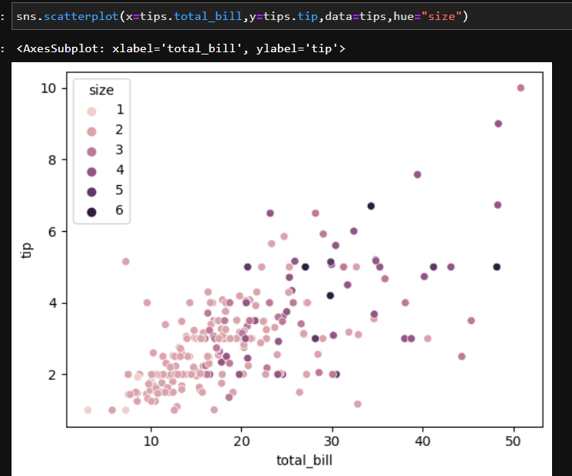

Relplot and scatter plot both gives the same visualization but use relplot for more relationships.

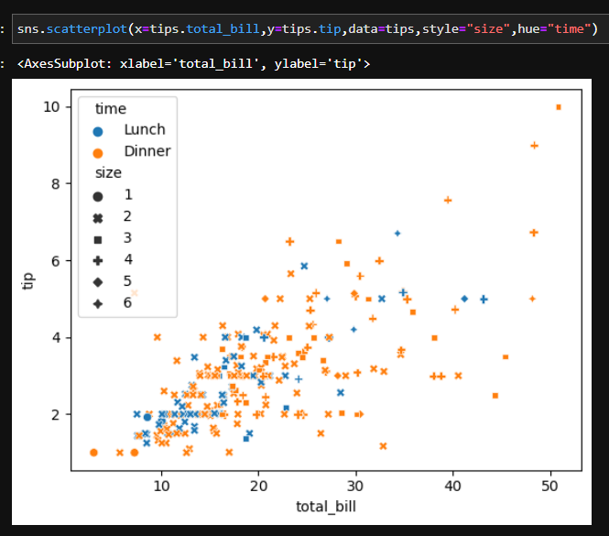

For categorical representation we will use cat plot

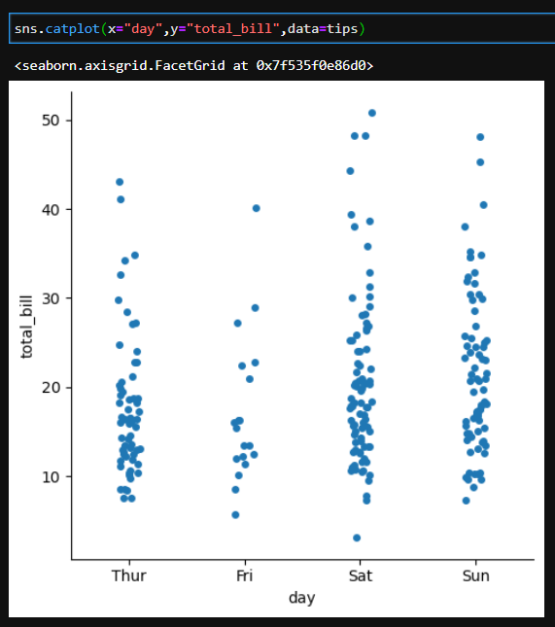

Jointplot :- This visualization consists of scatterplot and histogram ( distribution plot) , histogram shows the distribution of x axis and its frequency as well as for y – axis . scatter plot is used for main analysis . x and y axis relationship.

Pairplot () in seaborn shows all the visualization of all the numerical columns in the data set.

]\

**Pivot function** is a function that allows you to reshape a dataset by converting values from one column into multiple columns, creating a pivot table or matrix-like representation. The pivot function is commonly used in pandas, a popular data analysis library in Python, to transform data into a desired format for further analysis or visualization.

**HEAT MAP :-**

Best Reference to learn seaborn heatmap.

Https://indianaiproduction.com/seaborn-heatmap/#:~:text=heatmap()%20fmt%20parameter%20%E2%80%93%20add%20text%20on%20each%20cell,-fmt%3A%20Pass%20value&text=The%20annot%20only%20help%20to,text)%20values%20on%20the%20cell.

**PLOTLY**

Plotly is another library for data visaulization , this is different from rest of the libraries , as it is executed in google colab , in this the visualization has some extra features , like if we hover the cursor to the graph then it will show points on it and also we can download the graph.

We can also change the mode like I have converted to line.

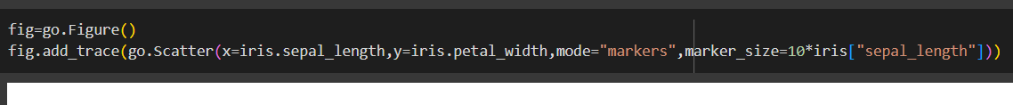

Bokeh

* 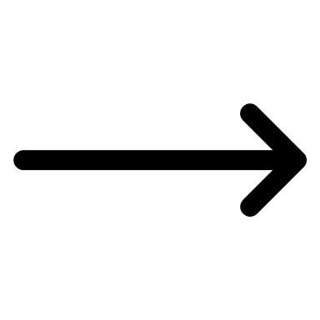What is the difference between add_trace function and data parameter in Figure function ?

So, the difference between add_trace function and data parameter is that add_trace fucntion add individual plot (trace) where as in data parameter we can add multiple trace

Syntax for data parameter Is go.Figure(data=[trace1,trace2,trace3…….])

For add_trace function is fig.add_trace(trace1)

Using the data parameter, you can define and include all the traces at once during the figure creation.

Using the add_trace function, you can add traces one by one to an existing figure.

* **Enumerate**

By using enumerate, we can conveniently access both the index and the value of each element in the data list, making it easier to iterate and perform operations based on the index or value during the loop.

**Scatter matrix plot :-**

scatter matrix plot is a plot technique which comes under plotly , this plot is equivalent to pair plot in seaborn but has amazing features which comes form plotly .

**Plotly Express: Plotly Express is a high-level interface built on top of Plotly Graph Objects. It provides a simplified API for creating a wide range of charts with less code. Plotly Express functions are easy to use and require minimal configuration. You can create interactive visualizations quickly using expressive syntax. It is suitable for users who want to create plots easily and don't need extensive customization options.**

**Example using Plotly Express:**

**Plotly Graph Objects: Plotly Graph Objects is a low-level interface that provides more control and flexibility. It allows you to create and customize visualizations with fine-grained control over each element. With Plotly Graph Objects, you define the chart components individually, such as traces, layouts, and annotations. It is suitable for users who require extensive customization or want to build complex visualizations.**

**Example using Plotly Graph Objects**

**:**